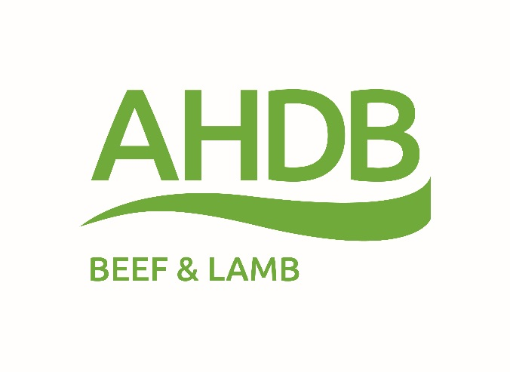
AHDB news release
For immediate release
… April 2017
Princely West Country fare in Italy
West Country beef, lamb with Protected Geographical Indication (PGI) and West Country Farmhouse Cheddar with Protected Designation of Origin (PDO) were on the menu for a wine, meat and cheese tasting hosted by Jill Morris, HM Ambassador in Rome on the occasion of HM The Prince of Wales and HRH The Duchess of Cornwal’s visit to Hotel Belmondo, Villa San Michelle in Fiesole, Tuscany, on Saturday 1 April. The event was attended by a very select number of wine producers and media.
The best of West Country produce was paired with some of the best wines from Tuscany including those from Sting’s estate Il Palagio.
J.P. Garnier, Head of Exports of AHDB says: “We are grateful for the support of HM The Prince of Wales during his short visit to Italy. We are very keen to develop sales of beef, lamb and cheese from the West Country. The products have been welcome by Italian distributors and are already attractively merchandised by some Italian retailers. Italian consumers value PGI and PDO products and the green, traditional West Country image has a favorable perception.”
“However, the Italians above all value the great taste, tenderness and consistency of West Country meats and the superior flavour of real matured Cheddar cheese. We hope this tasting will contribute to establish them further in Italy.”
- Ends -
Notes to editors
AHDB is a statutory levy board, funded by farmers, growers and others in the supply chain. Our purpose is to inspire our farmers, growers and industry to succeed in a rapidly changing world. We equip the industry with easy to use, practical know-how which they can apply straight away to make better decisions and improve their performance. Established in 2008 and classified as a Non-Departmental Public Body, it supports the following industries: meat and livestock (cattle, sheep and pigs) in England; horticulture, milk and potatoes in Great Britain; and cereals and oilseeds in the UK. AHDB’s remit covers 72 per cent of total UK agricultural output. Further information on AHDB can be found at www.ahdb.org.uk
Contact
For further information contact Jenny Waddington, AHDB Media and PR Manager on 024 7647 8910 or jenny.waddington@ahdb.org.uk
@AHDB_BeefLamb
YouTube
beefandlamb.ahdb.org.uk

